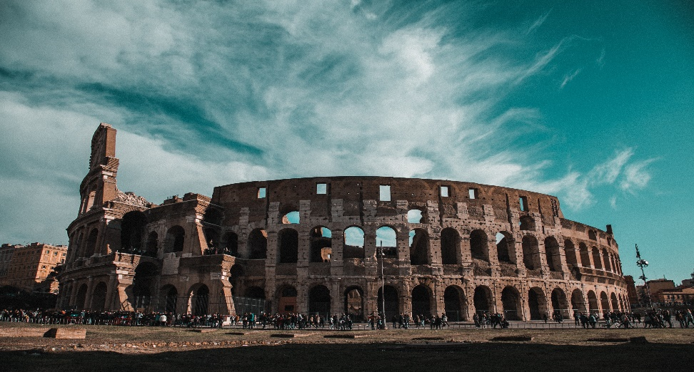

History of Colosseum

The Colosseum, also known as the Flavian Amphitheatre, is an ancient Roman amphitheater located in the center of Rome, Italy. It is one of the most iconic symbols of ancient Rome and has a rich history. Here are eight key points in the history of the Colosseum:

1. \*Construction (70-80 AD):\* The construction of the Colosseum began in 70 AD during the reign of Emperor Vespasian and was completed in 80 AD under his son Titus. It was built on the site of a drained lake in the heart of Rome.

2. \*Purpose and Use:\* The Colosseum was primarily used for public spectacles and entertainment, including gladiator contests, animal hunts, mock sea battles, and various theatrical performances. It could hold between 50,000 and 80,000 spectators.

3. \*Architecture:\* The Colosseum is an architectural marvel. It is an elliptical structure made of concrete and sandstone, with a system of arches, columns, and vaults. It is considered one of the finest examples of Roman engineering and architecture.

4. \*The Name:\* The name "Colosseum" is believed to have been derived from a colossal statue of Nero that once stood nearby, known as the Colossus of Nero. However, the official name was the Flavian Amphitheatre, named after the Flavian dynasty of emperors who built it.

5. \*Historical Significance:\* Beyond its entertainment value, the Colosseum played a significant role in Roman society. It served to demonstrate the power and wealth of the emperors and helped maintain social order by providing a distraction for the populace.

6. \*Decline and Abandonment:\* The Colosseum was used for various events for centuries, but with the decline of the Roman Empire, its use as an entertainment venue diminished. It eventually fell into disrepair and was abandoned.

7. \*Restoration and Preservation:\* Over the centuries, the Colosseum suffered from earthquakes, fires, and stone-robbers. In the 18th century, efforts to preserve and restore the monument began, and these efforts continue to this day.

8. \*Tourist Attraction:\* Today, the Colosseum is one of Rome's most popular tourist attractions and a UNESCO World Heritage site. It stands as a symbol of Rome's grandeur and serves as a testament to the advanced engineering and architectural achievements of the Roman Empire.

The Colosseum's enduring legacy is a testament to the cultural and historical significance of ancient Rome, and it remains a powerful symbol of both the grandeur and the brutality of that era.